

Annexure V: Project Report Cover page/ Title page

Mini Project
-
1
Report
On

➢

Time Table
Management System

B
y

POORNIMA ANDHARE

(
MITU21BTIT
0043)

VISHAL SHINDE

(
MITU21BTIT
0065)

OMKAR RASAL

(
MITU21BTIT
0042)

Under the guidance of

Prof. KANCHAN KAT
A
KE MAM

Department of Information Technology

Academic Year :
2022
-
2023

Annexure vi: Project Approval sheet

A

Project

on

➢

(
Time Table
Management System
)

Is successfully completed by

POORNIMA ANDHARE

(
MITU21BTIT
0043)

VISHAL SHINDE

0065)
(
MITU21BTIT

OMKAR RASAL

(
MITU21BTIT
0042)

At

Department of
Information Technology

Project Guide

Project Co
-
Ordinator

Prof.

Kanchan Katake

Prof. Ashvini Jadhav

.

Head of Department
Prof. Rekha Sugandhi

Schedule of Project Work

Semester I
Sr. No | Activity Scheduled | Plan Date | Actual date | sign guide /Remark
1 | Registration of Project Groups (Formation of Group) | 3/08/22
2 | Allocation of Guide/Project Guidance by project guide(Discussion on Project topic with Project Guide) | 10/08/22
3 | Project Topic Submission to guide (3 topic by each group) | 17/08/22
4 | Project Topic Presentation (Review -1 in front of PANEL) | 24/08/22
5 | Submission of Introduction of  Project(Synopsis) (To Project Guide and  Project Coordinator in the Prescribed Format) Demo-1 | 7/09/22
 | Poster presentation /Project idea presentation  Demo-2 | 7/09/22
6 | Understand existing available  projects/research paper execute and run code | 14/09/22
7 | Internal Review by guide about Project code | 21/09/22
8 | Status of Project suggestion by( panel members and guide) | 28/09/22
9 | Verification of Project PPT  By Internal Guide (before submission of Preliminary Project Report) | 5/10/22

10 | Project Review – II (Review by PANEL ) Project with code and execution | 12/10/22
11 | Submission of Final Preliminary Project Report in Prescribed Format/Project  suggestion by( panel members and guide) in Project Review – II | 19/10/22
12 | Project Review – III (Review by PANEL ) | 26/10/22
 | Project Review – IV (Review by INDUSTRY EXPERT ) | 26/10/22  AND  3/10/22
13 | FINAL MINI PROJECT EXAM | 25/11/22
 | Term-work Evaluation

Sr no. | INDEX | Page no.
1. | Project introduction | 6
2. | Keywords | 8
3. | System Analysis | 9
4. | Code | 14
5. | Implementation and Testing | 17
6. | Future Enhancement and Limitations | 19
7. | Conclusion | 20
8. | Reference sites | 21

Project Introduction

Timetable management project in java with complete source code. Timetable management system is a project which is developed to provide support to students in a college or an institute. how to develop a web application in Java with JSP, servlet, MySQL, Maven and MVC .
Time Table management system is a project which aims in developing a computerized system to maintain all the daily work of Time Table .This project has many features which are generally not available in normal Time Table management systems like facility of user login and a facility of teachers login .It also has a facility of admin login through which the admin can monitor the whole system .It also has facility of an online notice board where teachers can student can put up information about workshops or seminars being held in our colleges or nearby colleges and librarian after proper verification from the concerned institution organizing the seminar can add it to the notice board . It has also a facility where student after logging in their accounts can see list of books issued and its issue date and return date and also the students can request the librarian to add new books by filling the book request form. The librarian after logging into his account ie admin account can generate various reports such as student report , issue report, teacher report and book report Overall this project of ours is being developed to help the students as well as staff of Time Table to maintain the Time Table in the best way possible and also reduce the human efforts.

what is the existing system?

To solve these problems they required a computerized system to handle all the works. They required a web based application that will provide a working environment that will be flexible and will provide ease of work and will reduce the time for report generation and other paperworks.

Scope & Goal:

The main purpose behind the proposed system is to provide a comprehensive computerized system, which can capture, collate and analyze the data from these wards and evaluate the impact of the program.

What are the issues/problems with the existing system?
- The existing system is not user-friendly system.
- Difficult to search record When there is no computerized system there is always a difficulty in searching of records if the records are large in number.
- Difficult to manage booking dates.

Organization of the report:

- Improvement in control and performance
The system is developed to cope up with the current issues and problems of Time Table.The system can add user, validate user and is also bug free.

- Save cost
After computerized system is implemented less human force will be required to maintain the Time Tablethus reducing the overall cost.

- Save time
Librarian is able to search record by using few clicks of mouse and few search keywords thus saving his valuable time.

KEYWORDS

- Spring Tool Suite 3 to run the program (Java)

- MySQL Workbench for the program’s database

- CSS files for font and background Styling of Webpage

- Use of Maven to download project dependencies

- Tomcat 8.5 for Server of the program

System Analysis

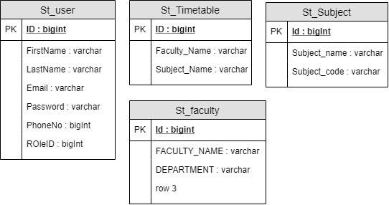

Fig 1 :- MySQL Chart for Database

Functional Decomposation:

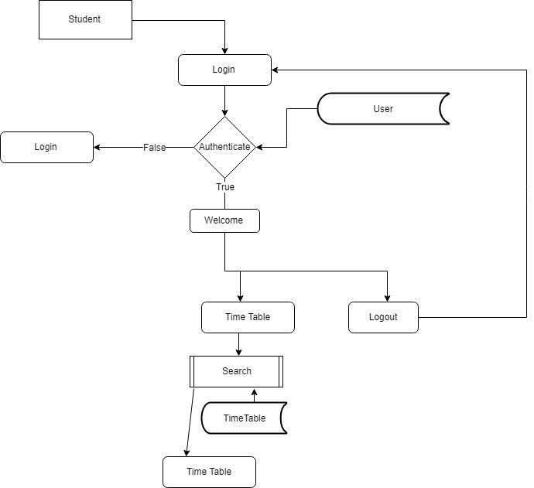

Fig 2 :- Flow Chart Of TimeTable Management Sysytem

Data validaton:

Procedures are designed to detect errors in data at a lower level of detail. Data validations have been integrated in the system in almost every area where there is a possibility for the user to commit errors. The system will not recognize invalid data.

Whenever an invalid data is keyed in, the system immediately prompts the user and the user has to again key in the data and the system will accept the data only if the data is correct. Validations have been integrated where necessary.

The system is designed to be a user friendly one. In other words the system has been designed to communicate effectively with the user. The system has been designed with pop up menus.

Different Type Of validation :
- Data type validation;
- Range and constraint validation;
- Code and Cross-reference validation; and ➢ Structured validation

Hardware & Software Requirement :

Hardware Interfaces
  - Minimum Hardware requirement
  - Processor: P4 3.0 GHz
  - RAM:1 GB or Higher
  - Monitor
  - Mouse

Software Interfaces
  - Minimum Software requirement
  - Java (JSP and Servlet)
  - Tomcat Server 8.5

All these types of software automatic configure inside operating system after installation it having Java, MySQL, Apache and operating system base configuration file, it doesn’t need to configure manually.

Code:

<%@page import="in.co.time.table.bean.HTMLUtility"%>
<%@page import="java.util.List"%>
<%@ page language="java" contentType="text/html; charset=ISO-8859-1" pageEncoding="ISO-8859-1"%>
<!DOCTYPE html PUBLIC "-//W3C//DTD HTML 4.01 Transitional//EN"
"http://www.w3.org/TR/html4/loose.dtd">
<html>
<head>
<meta http-equiv="Content-Type" content="text/html; charset=ISO-8859-1">
<title>Insert title here</title>
</head> <body
style="background-image: url('img/MIT.jpg'); background-size: cover;" class="img-responsive">

<%@ include file="Header.jsp"%>

<jsp:useBean id="bean" class="in.co.time.table.bean.TimeTableBean"
scope="request"></jsp:useBean>

<%
List faculty = (List) request.getAttribute("facultyList");
List subject = (List) request.getAttribute("subjectList");
String facultyName = (String) request.getAttribute("FacultyName");
String subjectName = (String) request.getAttribute("SubjectName");
%>
<div class="body">
<div class="modal-dialog orsform_modal-dialog">
<div class="modal-content">

<div class="modal-heading">

<h2 class="text-center">Add TimeTable</h2>

<center>
<b><font class="text-center" color="red">
</font></b> <b><font
color="black"></font></b>
</center>
</div>

<hr>

<div class="modal-body">
<form action="TimeTableCtl" role="form" method="post" class="form">

<div class="form-group">
<label for="login">Faculty Name</label>
<div class="input-group">
<span class="input-group-addon">
<span
class="glyphicon glyphicon-user"></span>
</span>

<%=HTMLUtility.getList("facultyId", String.valueOf(bean.getFacultyId()), faculty)%>
</div>
<b><font color="red"> <%=(facultyName
!= null) ? facultyName : ""%></font></b>
 | </div>
 | <div class="form-group">
for="password">SubjectName</label> | <label
 | <div class="input-group">
<span | <span class="input-group-addon">
glyphicon-lock"></span> | class="glyphicon
 | </span>
<%=HTMLUtility.getList("subjectId", String.valueOf(bean.getSubjectId()), subject)%>

</div>
<b><font color="red"> <%=(subjectName
!= null) ? subjectName : ""%></font></b>
</div>

<div class="form-group text-center"> <input type="submit" class="btn btnsuccess btn-lg"
value="Submit"> <input type="reset"
class="btn btn-success btn-lg" ss value="Reset"><br>
</div>

</form>
</div>

</div>

</div>

<div style="width: 100px; height: 256px;"></div>

<%@ include file="Footer.jsp"%>

</div>
</body> </html>

Implementation and Testing :

Black-Box Testing:

Black Box Testing, also known as Behavioral Testing, is a software testing method in which the internal structure/ design/ implementation of the item being tested is not known to the tester. These tests can be functional or nonfunctional, though usually functional.

This can be following way:

- Input interfacing
- Processing ➢ Output interfacing

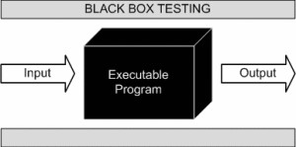

This method is named so because the software program, in the eyes of the tester, is like a black box; inside which one cannot see. This method attempts to find errors in the following categories:

- Incorrect or missing functions

- Interface errors

- Errors in data structures or external database access

- Behavior or performance errors

- Initialization and termination errors

White-Box Testing:

White Box Testing ,also known as Clear Box Testing, Open Box Testing, Glass Box Testing, Transparent Box Testing, Code-Based Testing or Structural Testing is a software testing method in which the internal structure/ design/ implementation of the item being tested is known to the tester.

The tester chooses inputs to exercise paths through the code and determines the appropriate outputs. Programming know-how and the implementation knowledge is essential.

White box testing is testing beyond the user interface and into the nittygritty of a system.
This method is named so because the software program, in the eyes of the tester, is like a white/ transparent box; inside which one clearly sees.

Futures Enhancement :

- In future we can expand this project to add more modules.

- Software can be accessed through internet also.

Limitation :

- In this system SMS facility is not available.

- In this system online payment is not available.

Conclusion:

This website provides a computerized version of Time Table management system which will benefit the students as well as the staff of the library. It makes entire process online where student can search books, staff can generate reports and do book transactions. It also has a facility for student login where student can login and can see status of books issued as well request for book or give some suggestions. It has a facility of teacher’s login where teachers can add lectures notes and also give necessary suggestion to Time Table and also add info about workshops or events happening in our college or nearby college in the online notice board. There is a future scope of this facility that many more features such as online lectures video tutorials can be added by teachers as well as online assignments submission facility , a feature Of group chat where students can discuss various issues of engineering can be added to this project thus making it more interactive more user friendly and project which fulfills each users need in the best way possible

Reference Sites :

- http://www.lisbdnet.com/definition-of-library-managemen/

- https://www.javatpoint.com/

